Project Report

EMBEDDED SYSTEMS

Automated Household Temperature Control System

Kamran Ali 13100174

Aim
The aim of the project was to observe and control the temperature of a chamber by implementing PID (Proportional, Integral and Differential) feedback control system (shown in figure 1) using Mini-6410. The GUI for temperature control and monitoring was developed through QTcreator. Moreover, a separate driver module was written for interfacing Mini-6410 with the hardware, consisting mainly of the temperature measurement through ADC and fan/heater control.

Hardware Setup
The temperature sensor that we have used is LM35. The AC lament lamp is used for heating purpose whereas the DC fan is used for cooling. We have used the PID controller to control this setup.

We are using LM35 as temperature sensors for the purpose of our project. The potential difference across this device changes with the temperature.
We have used Analog to Digital Converter on mini-6410 to convert the voltage (corresponding to the existing temperature) in to digital signal, so that it could be fed to mini-6410 for further processing.
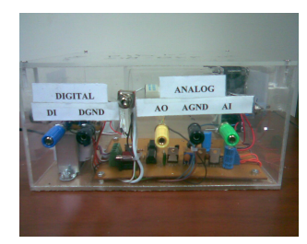
Figure 1

Overview of the System:

Driver Interface

Following is the driver we wrote for interfacing mini-6410 ADC with the chamber’s temperature sensor and communication of the PID control (running on QT application) to the chamber’s digital input for turning heater/fan ON & OFF.

#include <linux/kernel.h>
#include <linux/module.h>
#include <linux/slab.h>
#include <linux/input.h>
#include <linux/init.h>
#include <linux/errno.h>
#include <linux/serio.h>
#include <linux/delay.h>
#include <linux/clk.h>
#include <linux/wait.h>
#include <linux/sched.h>
#include <linux/cdev.h>
#include <linux/miscdevice.h>
#include <asm/io.h>
#include <asm/irq.h>
#include <asm/uaccess.h>
#include <mach/map.h>
#include <mach/regs-clock.h>
#include <mach/regs-gpio.h>
#include <plat/gpio-cfg.h>
#include <mach/gpio-bank-q.h>
#include <mach/gpio-bank-e.h>
//#include <mach/map.h>
#include <plat/regs-timer.h>
#include <plat/regs-adc.h>

static void __iomem * base_addr;
static struct clk *adc_clock;
int value;
int temp1, temp2, temp3, temp4,tmp;
int t = 0;

#define __ADCREG(name) (*(volatile unsigned long *)(base_addr + name))
#define ADCCON __ADCREG(S3C_ADCCON) // ADC control
#define ADCTSC __ADCREG(S3C_ADCTSC) // ADC touch screen control
#define ADCDLY __ADCREG(S3C_ADCDLY) // ADC start or Interval Delay
#define ADCDAT0 __ADCREG(S3C_ADCDAT0) // ADC conversion data 0
#define ADCDAT1 __ADCREG(S3C_ADCDAT1) // ADC conversion data 1
#define ADCUPDN __ADCREG(S3C_ADCUPDN) // Stylus Up/Down interrupt status

#define PRESCALE_DIS (0 << 14)
#define PRESCALE_EN (1 << 14)
#define PRSCVL(x) ((x) << 6)
#define ADC_INPUT(x) ((x) << 3)
#define ADC_START (1 << 0)
#define ADC_ENDCVT (1 << 15)

#define DEVICE_NAME "adc_dev"
static int adc_init()
{
unsigned int preScaler = 0XFF;
ADCCON = (1<<14)|(preScaler<<6)|(1<<3)|(0<<2);
ADCCON |= ADC_START;
return 0;
}
static int adc_open(struct inode *inode ,struct file *filp)
{
adc_init();
return 0;
}
static int adc_release(struct inode *inode,struct file *filp)
{
return 0;
}
static ssize_t adc_read(struct file *filp,char __user *buff,size_t size,loff_t *ppos)
{
ADCCON |= ADC_START;
while(ADCCON & 0x01);//check if Enable_start is low
while(!(ADCCON &0x8000));

// printk("%d\n",ADCDAT0 & 0x3ff);

return (ADCDAT0 & 0x3ff);
}

static ssize_t MyWrite (struct file *filp, const char * buf, size_t count, loff_t *f_pos) {
char buffer[100];
int ret;
int a,b;

ret = copy_from_user(&buffer,buf,count);
*f_pos+=count;
sscanf(buffer,"%d",&value);
//printk("%d\n",value);
//if (buffer[count-1]!='\n') printk("\n");

temp2 = readl(S3C64XX_GPQDAT);
temp4 = readl(S3C64XX_GPEDAT);

b = (value << 1) & 0x0000000E;
a = (value >> 2) & 0x0000001E;

t = a;
t = ((t&(1<<3)) << 1) | ((t&(1<<4)) >> 1);
t = (a&(6)) | t;
a = t;

temp2 &= (a|0xFFFFFFE1);
temp2 |= a;
writel(a,S3C64XX_GPQDAT);

temp4 &= (b|0xFFFFFFF1);
temp4 |= b;
writel(b,S3C64XX_GPEDAT);

return count;
}

static struct file_operations dev_fops =
{
.owner = THIS_MODULE,
.open = adc_open,
.release = adc_release,
.read = adc_read,
.write = MyWrite,
};

static struct miscdevice misc =
{
.minor = MISC_DYNAMIC_MINOR,
.name = DEVICE_NAME,
.fops = &dev_fops,
};

static int __init dev_init()
{
int ret;

base_addr =ioremap(SAMSUNG_PA_ADC,0X20);
if(base_addr == NULL)
{
printk(KERN_ERR"failed to remap\n");
return -ENOMEM;
}

adc_clock = clk_get(NULL,"adc");
if(!adc_clock)
{
printk(KERN_ERR"failed to get adc clock\n");
return -ENOENT;
}
clk_enable(adc_clock);

// Pins

// Initiallizing the registers
tmp = readl(S3C64XX_GPECON); //32 bits
tmp = (tmp & 0xFFF1111F); //GPE 1-4
tmp|= (0x00011110);
writel(tmp, S3C64XX_GPECON);

tmp = readl(S3C64XX_GPEDAT);
tmp &= (0xFFFFFFE1);// 1110 0001
writel(tmp, S3C64XX_GPEDAT);
tmp = readl(S3C64XX_GPQCON); //32 bits
tmp = (tmp & 0xFFFFF555); //clear GPQ 1-4
tmp|= (0x00000555);
writel(tmp, S3C64XX_GPQCON);

tmp = readl(S3C64XX_GPQDAT);
tmp &= (0xFFFFFFE1);// 1110 0001
writel(tmp, S3C64XX_GPQDAT);

ret = misc_register(&misc);
printk("dev_init return ret:%d\n",ret);
return ret;
}
static void __exit dev_exit()
{
iounmap(base_addr);

if(adc_clock)//disable adc clock
{
clk_disable(adc_clock);
clk_put(adc_clock);
adc_clock =NULL;
}
misc_deregister(&misc);

}
module_init(dev_init);
module_exit(dev_exit);

MODULE_LICENSE("GPL");
MODULE_AUTHOR("Kamran");

Connections of Analog and Digital Terminals

We have used ‘A1’ as input to the Analog to Digital Converter of mini 6410, and ‘D1’ was connected to the output of mini6410, which was used to turn-on/turn-off the Bulb.
When we provide 0V to the system then it turn-off the bulb and when we apply 5V to the system then it turns on the bulb.

QT application
The user is able to set the required temperature through our interactive user friendly QT application and this application then controls the temperature of the room by turning on the fan if the room is too hot and would turn on the bulb/heater if the room is cold. Our system monitors the temperature at regular intervals and makes the decisions (whether to turn on the fan or bulb) based on the temperature sensed.
Depending on the difference between the desired temperature (entered by the user) and the actual temperature, we minimize the overshoot or undershoot, using the PID controller.
Here is the snapshot of the GUI we made on QTcreator:
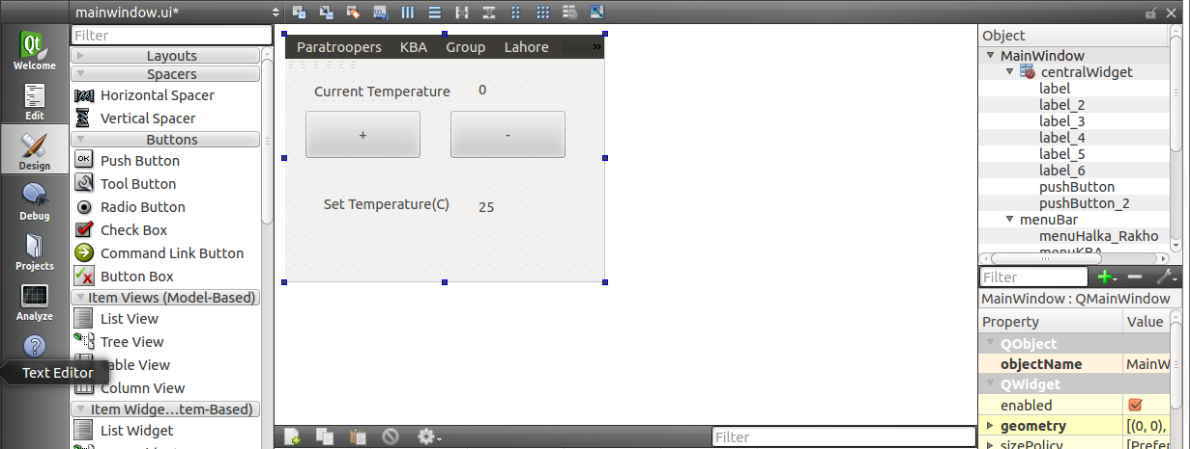

PID coefficient estimates using MATLAB:
Matlab provides support for estimating PID coefficients. To find these coefficients, Matlab gives certain stimuli to the system and based on the response it identifies the system and associates with it a system function. Based on this system function it gives estimates of PID coefficients. These coefficients were then tested using Matlab by interfacing our model with a computer hosting Matlab through a DAC card. Following is the code used:
clc
clear all
AI = analoginput('nidaq', 'Dev9');
addchannel(AI, 1);
set(AI,'InputType', 'singleended');

AO = analogoutput('nidaq', 'Dev9');
addchannel(AO, 1);

reftemp = zeros(1,20000);
currtemp = zeros(1,20000);
error = zeros(1,20000);
control = zeros(1,20000);

reftemp(1:6000) = 55;
reftemp(6001:20000) = 45;

for i =1:1:20000
currtemp(i) = 100*getsample(AI);
error(i) = reftemp(i) - currtemp(i);
if (i>1)
control(i) = -1*( 10*error(i)+9.5*error(i-1)+control(i-1) );
else
control(i) = 10*error(i);
end
putsample(AO,control(i));
end

plot(currtemp);
Following was the response of the system:
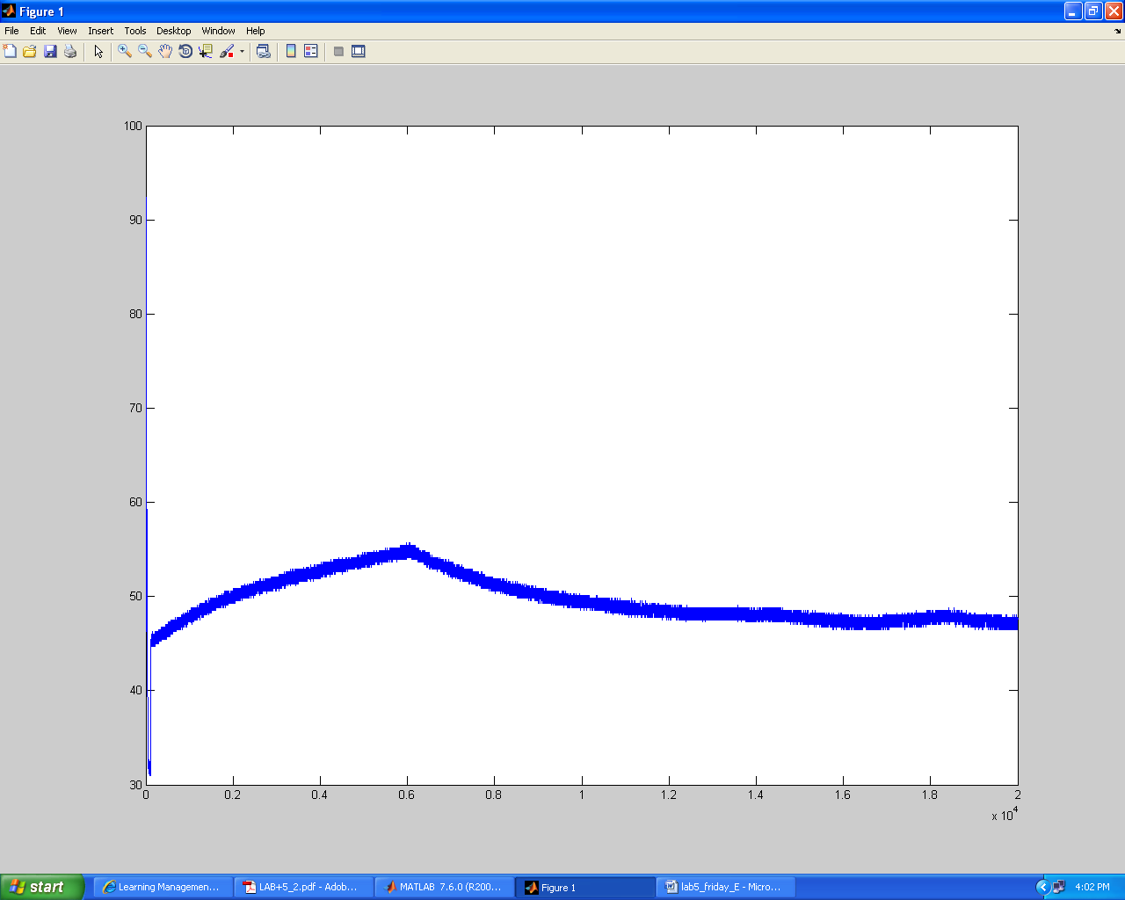

However, since these coefficients were calculated using a DAC card and Matlab, the coefficients were not accurate for MINI6410. But they did provide us with an interval within which we could find the coefficients that worked best for our system.

Final PID Control implementation on QT
After using the values of Proportional, Integral and Differential control coefficients from the Matlab simulation system we implemented the PID control on QT using C++. Following is the C++ code:
MainWindow::MainWindow(QWidget *parent) :
QMainWindow(parent),
ui(new Ui::MainWindow)
{
fd = open("/dev/adc_dev",O_RDWR); // Read write enable
ui->setupUi(this);

timer = new QTimer(this);
connect(timer, SIGNAL(timeout()), this, SLOT(update()));
timer->start(100);

reftemp = 45;
curr_temp = 0;
curr_temp_prev = 0;
error = 0;
error_prev = 0;
control = 0;
control_prev = 0;
set_temp = 55;
}
MainWindow::~MainWindow()
{
delete ui;
}
void MainWindow::update()
{
// Temperature control
curr_temp = 330*read(fd,NULL,0)/1023;
error = reftemp-curr_temp;
control = -1*(10*error+9.5*error_prev+control_prev);
//output control signal here
curr_temp_prev = curr_temp;
error_prev = error;
control_prev = control;

if (curr_temp > set_temp)
{
sprintf(str,"%u",0xFFFFFFFF);
write(fd,&str,10);
}
else
{
sprintf(str,"%u",0x00000000);
write(fd,&str,10);
}
sprintf(str,"%u",curr_temp);
ui->label_6->setText(str);
printf("%u\n",curr_temp);
}

void MainWindow::on_pushButton_2_clicked() // increase temperature
{
set_temp++;
sprintf(str,"%u",set_temp);
ui->label_2->setTelxt(str);
}

void MainWindow::on_pushButton_clicked() // decrease temperature
{
set_temp--;
sprintf(str,"%u",set_temp);
ui->label_2->setText(str);
}

Conclusion
The actual behavior of the PID control using mini-6410 matched with the simulations run on Matlab using the same values of P, I and D marking the successful completion of our project. The project can be used for controlling HVAC (heating, ventilation, and air conditioning) systems of Educational Institutions, Industrial zones, Factories and Apartments.

