**Water Filling Algorithms for Power Allocation and Control in Cognitive Radio Systems**

Project report

By

Kamran Ali (13100174)

Isfar Tariq (13100151)

Advisor

Dr. Ijaz Haider Naqvi

[ijaznaqvi@lums.edu.pk]

Reader

May 13, 2013

Department of Electrical Engineering

Syed Babar Ali School of Science and Engineering

Lahore University of Management Sciences, Pakistan

**1 Introduction**

**1.1 Cognitive Radios**

With the rapid development of wireless communications, frequency spectrum is becoming a very precious resource and scarcity of the spectrum is a serious problem. In some cases, the spectrum bands are not efficiently utilized because licensed users do not always occupy their spectrum and unlicensed users are not allowed to operate in such spectrum bands. This governance leads to unbalanced spectrum utilization[1][4].

In [2] Joseph Mitola proposed Cognitive radio (CR) systems to exploit the unbalanced spectrum utilization and by allowing Secondary Users (SUs) to use the idle spectrum of licensed users or Primary Users (PUs) to gain a higher spectrum utilization. Figure 1 shows the Cognitive Radio Scenario and Cycle respectively. Hakin defines cognitive radio like this in one of his most cited papers [4] :

“*Cognitive radio is an intelligent wireless communication system that is aware of its surrounding environment (i.e., outside world), and uses the methodology of understanding-by-building to learn from the environment and adapt its internal states to statistical variations in the incoming RF stimuli by making corresponding changes in certain operating parameters (e.g., transmit-power, carrier-frequency, and modulation strategy) in real-time, with two primary objectives in mind:*

* *Highly reliable communications whenever and wherever needed.*
* *Efficient utilization of the radio spectrum.*

So the motivation behind the Cognitive Radio was the significant under-utilization of the radio spectrum. Cognitive Radio solves the spectrum under-utilization problem in a tightly inter-coupled pair of ways:



Figure 1: Cognitive Radio Scenario and Cycle [10]

1. Sense the radio environment to detect spectrum holes in terms of both time and location.
2. Control employment of the spectrum holes by secondary users efficiently, subject to the constraint: *The total power in each spectrum hole does not exceed a prescribed limit.*

Cognitive radios have been proposed as a mean to implement efficient reuse of the licensed spectrum. The key feature of cognitive radios is their ability to recognize their communication environment and independently adapt the parameters of their communication scheme to maximize the *quality of service* (QoS) for the secondary (unlicensed) users while minimizing the interference to the primary users. However, there are many challenges across all layers of a cognitive radio system design, from its application to its implementation [4]. Our focus is on the Transmit Power Control functionality of the Cognitive Systems.

**1.2 Transmit-Power control in Cognitive Radios**

According to Haykin [4], there are five major functional blocks of Cognitive Radio which include Spectrum sensing, Predictive modeling, Transmit-power control, Dynamic spectrum management and Packet routing. Among these topics, our research is related with Transmit-power control (TPC). The action of TPC in Cognitive radios is to maximize data rate of each user subject to power constraints.

In conventional wireless communications built around base stations, transmit-power levels are controlled by the base stations so as to provide the required coverage area and thereby provide the desired receiver performance. On the other hand, it may be necessary for a cognitive radio to operate in a decentralized manner, thereby broadening the scope of its applications. In such a case, some alternative means must be found to exercise control over the transmit power [4].

Several algorithms have been proposed containing protocols and co-operative ad hoc network configurations. These co-operative mechanisms apply fundamentals of Game Theory, Stochastic Games or Markov games and Water Filling to accomplish multiple access by users to cognitive radio channel.

Our research deals with the Water Filling (WF) algorithms. Many algorithms related to WF in cognitive environment have been proposed. While the water filling algorithms would work well for an individual cognitive radio and give results close to the optimum however this may not true for the case of overall network. This is because the overall optimum of the system is determined by the maximization of the combined bandwidth available to all the nodes. However, by using the water filling alone would although cause the bandwidth of the individual node to increase but the overall bandwidth of the system might decrease resulting in a non-optimum condition. So there is a need to build a cognitive network in order to have different water level for different frequencies. In the next section we will be giving the review of some algorithms presented in the papers we scrutinized.

**2 Literature Reviews**

**2.1 Majed et al [9]**

This paper provides one of the fundamental Water Filling approaches towards TPC in Cognitive Radio Networks. In this contribution, the idea of using cognitive radio to reuse locally unused spectrum to increase the total system capacity is discussed. A multiband/wideband system is considered in which the primary and cognitive users wish to communicate to different receivers, subject to mutual interference and assume that each user knows only his channel and the unused spectrum through perfect sensing. Under this scheme, a cognitive radio will listen to the channel and, if sensed idle, will transmit during the voids. A constraint is imposed such that users successively transmit over available bands through proper water filling. Within this setting, the total spectral efficiency of the cognitive radio system as well as the spectral efficiency gains is derived and it is proved that the overall system spectral efficiency can be improved by considering cognitive communications in the system.

An asynchronous TDD (Telecommunications Device for the Deaf ) communication scenario in which the primary and cognitive users wish to communicate to different receivers, subject to mutual interference in a heterogeneous network where devices operates in a wideband/multiband context.

Cognitive users listen to the wireless channel and determine, either in time or frequency, which part of the spectrum is unused. Then, they successively adapt their signal to fill detected voids in the spectrum domain. Each transmitter Tl estimates the pilot sequence of the receiver Rl in order to determine the channel gain. In a TDD mode, if the channel is estimated in one way, it becomes known the other way. Thus, each user l is assumed to know only his proper channel gain hl and the statistical properties of the other links.

The primary user comes first in the system and estimates his channel gain. Then, cognitive users come after in an asynchronous way so that they will not transmit at the same moment. Within this setting, the primary user is assumed not to be aware of the cognitive users. Then, he communicates with his receiver in an ad-hoc manner while a set of cognitive radio transmitters that are able to reliably sense the spectral environment over a wide bandwidth, decide to communicate with their respective receivers only if the communication does not interfere with the primary user. Thus, a device transmits over a certain sub-band only when no other user does.

Transmit powers are the allocated for each user in order to maximize his transmission rate over a total power budget constraint. In fact, when channel state information is made available at the transmitters, users know their own channel gains and thus they will adapt their transmission strategy relative to this knowledge. The corresponding optimum power allocation is the Water Filling allocation. Spectral Efficiency Analysis and the achievable performance when devices operate in a wide-band context (when number of sub-bands approach to very large values) are discussed further.

**2.2 Haykin [4]**

In [4], Haykin has proposed iterative WF algorithms for Two-user and Multi-user Scenarios. The paper is very highly sited and presents the general topics of research in Cognitive Systems with great explanation. In start of the WF section, the assumptions about the environment have been stated which are : (1) Communication across a channel is asynchronous, (2) SNR gap is large enough to assure reliable communication under operating conditions all the time. The interference temperature limit should not be violated when jointly maximizing the data rates of Secondary Users. Thus, there is a tradeoff: increasing the transmit-power level of any one transmitter has the undesirable effect of also increasing the level of interference to which the receivers of all the other transmitters are subjected.

2-user scenario WF algorithm is then presented. After taking cross-coupling into account very effectively based on the assumption that the receivers do not perform any form of interference-cancellation irrespective of the received signal strengths, a competitive optimization problem is stated which is in accordance with the WF procedure. An assumption implicit in the WF solution presented is that each transmitter of cognitive radio has knowledge of its position with respect to the receivers in its operating range at all times.

Iterative two-loop WF algorithm is introduced for the distributed transmit-power control of a multi-user radio environment. Viewing the multi-user radio environment as a non cooperative game and assuming the availability of an adequate number of spectrum holes to accommodate the target data-transmission rates, the algorithm proceeds as follows : 1) initialization-initial power distribution across ‘n’ users is set to 0, 2) Inner loop (iteration)-each user performs WF according to it’s own power constraint with interference from nodes applying WF first into account, 3) Outer loop (iteration)-After the inner iteration is completed, the power allocation among the users is adjusted and 4) Confirmation step-the transmission data rates of all the users are checked.

For distributively live within the permissible rate region, the transmitter needs to be equipped with a centralized agent that has knowledge of the channel capacity (through rate-feedback from the receiver) and multi-user path-loss matrix (by virtue of geographic awareness). The centralized agent is thereby enabled to decide which particular sets of target rates are indeed attainable. The algorithm, explanations and the background material is very well presented.

**2.3 Hasan et al [11]**

Efficient and reliable power allocation algorithm in Cognitive radio (CR) networks is a challenging problem. Traditional water-filling algorithm is inefficient for CR networks due to the interaction with primary users. This paper considers another aspect of CR networks for power allocation in the secondary user sub-carriers is defined as reliability/availability of sub-carriers or primary user activity for power allocation. System is modeled in a way to allocate more power to sub-carriers that are more reliable. Reliability means, the sub-carriers that are available often than the one, which gets busy very quickly. Such a behavior is observable when there are more than one sub-channel that belong to different primary users. These primary users differ on their activity or usage of their licensed band.

This risk-return model incorporates the sub-channel availability by defining an average rate loss function in presence of a primary user. The advantage of this model is that it takes into account channel reliability based on primary user activity for power allocation that was not considered before. The cost function gives the rate loss whenever primary user reoccupies the sub-channel. Optimal allocation solution for such a model is no longer the general water-filling solution. For a special case of linear loss function, the optimal power allocation approach turns out to be water filling with different water levels for sub-carriers belonging to the different primary users. These water levels are higher for the sub-carriers, which have lesser primary user activity.

Two heuristic suboptimal algorithms, which are, also water filling with different water levels for sub-channels belonging to different primary users are also proposed. The simulation results and comparison of the performance for these algorithms with respect to water-filling algorithm are provided in the end.

**2.4 Kennedy Ifeh [12]**

In the research report by Kennedy Ifeh on “Transmit-power control for cognitive radio networks: Challenges, requirements and options” the author discusses the concept of cognitive network for finding the overall optimum solution. Cognitive networks can exist as either a cooperative or a non-cooperative scheme. Cooperation among cognitive users requires that all participants agree on the best strategies for coalition however, this scheme requires a great amount of signaling causing information overhead and co-channel interference caused by communication between users. On the other hand, in a non-cooperative scheme, the users access the network by distributive means, there is no need for overbearing signalling, and information overhead but it causes poor utilization efficiency because individual users selfishly aim at maximizing their revenues. Therefore, this motivates us to modify our method of simple water filling and to modify it by using concepts from game theory. The author discusses and presents results for both the iterative water filling and the then the no regret algorithm based on the game theory. The author also presents a hybrid of the two methods that would give better results.

**2.5 Fan Wang [13]**

The technical report by FanWang, Marwan Krunz, and Shuguang Cui on “Spectrum Sharing in Cognitive Radio Networks” also gives a similar study in which the authors try to adaptively and efficiently allocate transmission powers and spectrum among the cognitive radios according to the surrounding environment. They provide a new joint power/channel allocation scheme that uses a distributed pricing strategy in order to improve the networks performance. They have modeled the spectrum allocation as a non-cooperative game as the users are unable to know of each other's choices. They proposed a distributive price-based iterative water-filling (PIWF) algorithm where the cognitive radios vary their power in the frequency spectrums in order to find the optimum operating point in the network. As we know that the cognitive radio aim is to maximize its own bandwidth, however this greedy behavior could result in an overall poor performance in the system since this might cause other nodes to operate at a point away from the optimum hence reducing the overall bandwidth of the network. In order to prevent this they form a problem into a game in which there is a pricing factor, which prevents the user from using larger amount of power in a certain band. They then solve this for finding the Nash equilibrium i.e. the optimum operating point of the network. They develop 2 different versions of the algorithms for this purpose one of which is sequential while the other one is parallel. They showed by the help of simulations that the parallel version converges faster than the sequential version. They later on also carried on discussing the MAC protocol in order to implement the price-based resource allocation algorithm in cognitive radios. By the help of simulations, they were able to show that the protocol was effective in improving the overall network throughput and reducing the average transmission power.

**2.6 Qilin Qi et al [3]**

In the paper by Qilin Qi, Andrew Minturn, and Yaoqing (Lamar) Yang “An Efficient Water-Filling algorithm for Power allocation in OFDM-Based Cognitive Radio systems” they present a new water filling algorithm for power allocation using Orthogonal Frequency Division Multiplexing (OFDM) based cognitive radio systems. Due to power constraints on the maximum power that can be transmitted in the cognitive radio system the conventional water-filling algorithm cannot be directly employed for power allocation in a cognitive radio system. So the authors present a novel algorithm based on iterative water-filling in order to overcome such limitations of energy. However the computational complexity for such an iterative water-filling is very high due to the calculation and the iterative approach taken. So the revisit the basics behind the water-filling algorithm and explore its features in order to simplify the algorithm and develop a new low-complexity algorithm using power-increment or power-decrement water-filling processes. In this method they slightly increment the power to find the new water level and repeat this process. For power-decrement solution they remove energy from the set and find the new water level. So in order to find the water level quickly they would first find the water level for set A which contains all possible nodes. Then if the maximum energy of one of the nodes is violated then they would decrease its energy in such a way that the energy is distributed in other nodes while its energy remain within bounds then they would do a power decrement of the node which energy has decreased. This process is repeated until all nodes energy is within the maximum limit. They have shown by the help of simulation that their proposed algorithms can achieve the optimal power allocation performance in less time than the iterative water-filling algorithms.

**3 Implementations**

For implementation, we choose the paper “An Efficient Water-Filling algorithm for Power allocation in OFDM-Based Cognitive Radio systems” by Qi, Andrew Minturn, and Yaoqing (Lamar) Yang. The paper is based on another paper of P. Wang, et al., “Power allocation in OFDM-based cognitive radio systems.” So in order to better understand the model used for the paper we studied this paper.

The model presented by the paper by P. Wang et al. consider the scenario in which multiple secondary users SUs are allowed to share the spectra designated for a primary user PU network shown in Fig.1

.

Although the existence of PU can be correctly detected, some techniques have to be considered to mitigate interference. The SU may have different interference and detection ranges as shown in Fig. 1, where the SU transmitter (Tx) is placed in the center of the operating circle, Dr is the radius of the detection range, and IR is the radius of the interference range.

In this case, SUs may not detect the existence of thesecond PU (PU2) transmitter because of large separation between them, but they can interfere with the PU2 receiver when the SU is transmitting. Meanwhile, it is difficult for the SU to detect the PU receiver. We can convert the problem from detecting the primary receiver to detecting the primary transmitter. Every PU has a circular protection region, of radius rp, in which the SU’s power cannot exceed a certain threshold. Since the PU’s transmitting power is also under the same total power constraint, the PU receivers in such an area centered by the PU transmitter can receive the signals transmitted by the PU transmitter. So the SU cannot transmit at a large power in band of PU in order to prevent interference of the PU receivers in the same area. When the PU receiver is located in the shaded area illustrated in Fig. 1, the SU will not interfere with the PU receiver even if the SU exceed their threshold power.

In the model discussed in paper each individual PU is allocated a sub channel. There are N subchannels corresponding to N PUs in the networks. Each sub channel consists of Lj (j=1, 2,... ,N) different subcarriers which have different channel gains. So the total number of subcarriers is $M=\sum_{j=1}^{N}{L_{j}}.$ therefore, in this OSA cognitive radio model, the SU Tx cannot transmit signal when the PUs are detected. While the PUs are not detected we have to make sure the transmit power is under a certain threshold. This condition can be formulated in as:

$$P_{j}≤G_{j}$$

Where

$$G_{j}=\left\{\begin{aligned}0 PU_{j}is detected \\ η{\left(d_{j}-r_{p}^{j}\right)}_{,}^{β_{j}} PU_{j}is not detected\end{aligned}\right.$$

Where Pj is the allocated power for SUs in subchannel j and ŋ is the threshold. For simplicity, the threshold in all sub channels is assumed to be the same. Gj is the interference constraint for subchannel j, dj is the distance between the SU transmitter and the PUj transmitter, and $r_{p}^{j}$ is the radius of the protection region in sub channel j, $β_{j}$ denotes the path attenuation factor. One scenario which we simulated in Matlab is given below. Red boxes are SU’s with their protection ring and Green ones are PU’s with their reliable detection ring.

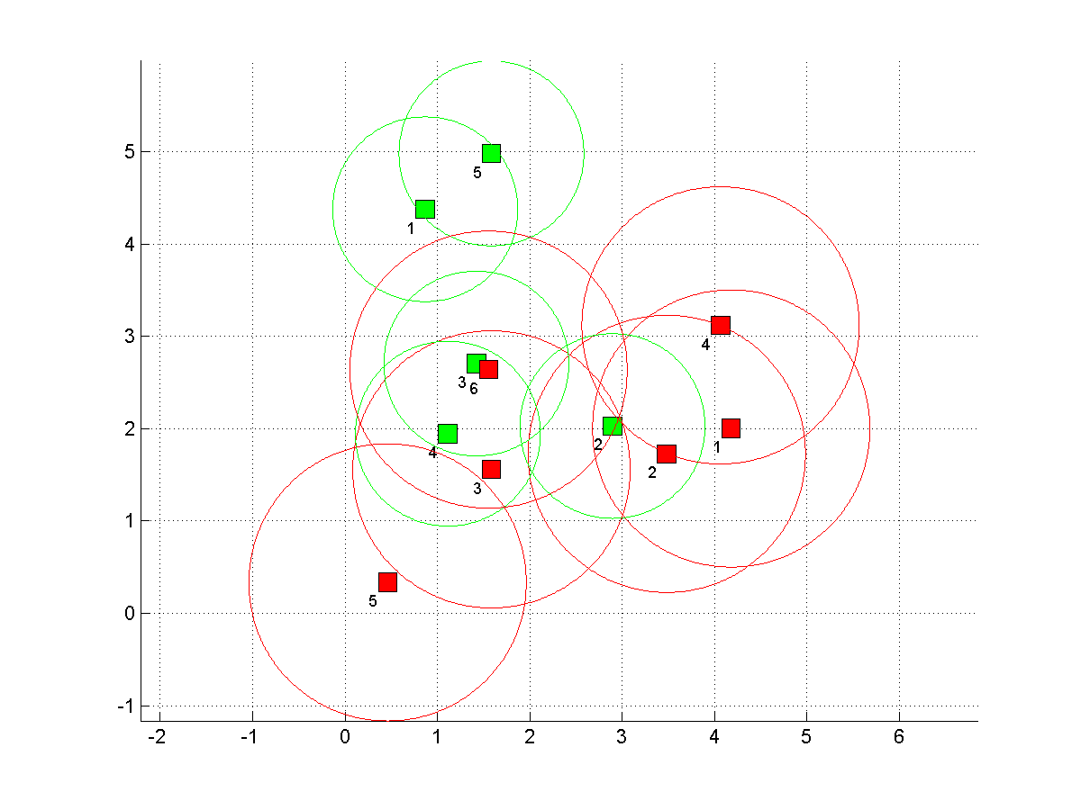

The OFDM communication model is of the form

$$y_{n}\left[m\right]=h_{n}x_{n}\left[m\right]+w\left[m\right] n=0,1,….,N-1$$

Where $x_{n}\left[m\right]$ is the input, $y_{n}\left[m\right]$ is the output, $w\left[m\right]$ is AWGN and $h_{n }$ is the channel gain. The normal water filling problem consist of optimizing capacity in the by allocating the power such that

$$C_{n}= \max_{P_{0},…P_{N-1} }{\sum_{n=0}^{N-1}{log⁡(1+\frac{P_{n}{\left|h_{n}\right|}^{2}}{N_{0}})}}$$

Under the constraint

$\sum_{k=0}^{N-1}{P_{n}}=P_{total }P_{n}≥0, n=0,1,…, N-1$

The above conditions are solved using Lagrangian multipliers using the Kuhn- tucker condition to get the optimum solution such that

$P_{n}=\left\{\begin{aligned}0 if \frac{1}{λ}<\frac{N_{0}}{{\left(\left|h_{n}\right|\right)}^{2}} \\ \frac{1}{λ}-\frac{N_{0}}{{\left(\left|h_{n}\right|\right)}^{2}} otherwise\end{aligned}\right.$

The model is modified to suit an OFDM based cognitive radio system described above by adding a following constraint of maximum power i.e. $\sum_{iϵI_i}{P_{i}=F_{j}≤G_{j} }$ where Pi is the power allocated to that subcarrier and Gj is the maximum power transmission capacity of that particular sub channel. One method to solve this problem is such as stated by the algorithm given as follows:



In this algorithm the approach used is to divide the given SNR data into sets A, B and C where A contain the set on which water filling is to be applied and B are the set on which we will not apply water filling. We start by finding the water level and using it find the appropriate value of energy allocated to each sub channel. If the energy of the sub channel is greater than the maximum energy allowed then make Fj equal to the maximum possible energy that can be allocated to that sub channel, apply water filling on that sub channel and move that sub channel to set B and remove it from set A. Then reapply the water filling on the set A and repeat the procedure until in a given iteration no more sub channel goes to set B. The paper discusses the proof regarding the optimality of this technique. This technique according to the paper provides a simple method to find the water level under the given constraint.

However, the paper by Qilin Qi proposes a new scheme that would give better results than the previous technique. The paper divides the SNR vectors in a similar manner to two sets A and B however; the paper claims that the results can be improved by modifying the algorithm. The paper proposes and proves two lemmas on basis of which it construct a new algorithm. The channel is divided into three categories as follows



The Hi is the sub channel carrier to noise ratio. Then the lemma 1 states that



And the lemma 2 is given as



The paper after using these two lemmas simplifies the process of water filling and reduces its complexity. The way the paper does it is by the result of lemma 1 is like a power increment done on a set and result of lemma 2 is like a power decrement done on the set. Since after the initial water filling and then checking the power constraint on each sub channel we get 2 sets. Set A in which all constraints are satisfied and set B where we have to reduce power to make its condition equal to the constraints. So now effectively we have to perform power decrement on set B and power increment on set A. Therefore, after this flow of power we will meet both the required constraints and achieve optimum maximum capacity. This process does not require water filling to be repeatedly done like the previous algorithm so gives the results in much lower time. The algorithm proposed by the paper is as follows:



The paper also gives simulation result according to this algorithm. The paper does simulation on taking the number of subcarriers in a channel to be 32 and change the PU to range from 1 to 40. It is assumed that the PUs are not transmitting. If the PUs are transmitting then algorithm would run even quicker as some channels would become unavailable. The paper declares that its results take 100 times less time than that proposed by the paper by P Wang. The graphs of the result are drawn below.



We used the help of these two papers performed simulations and got the following results.

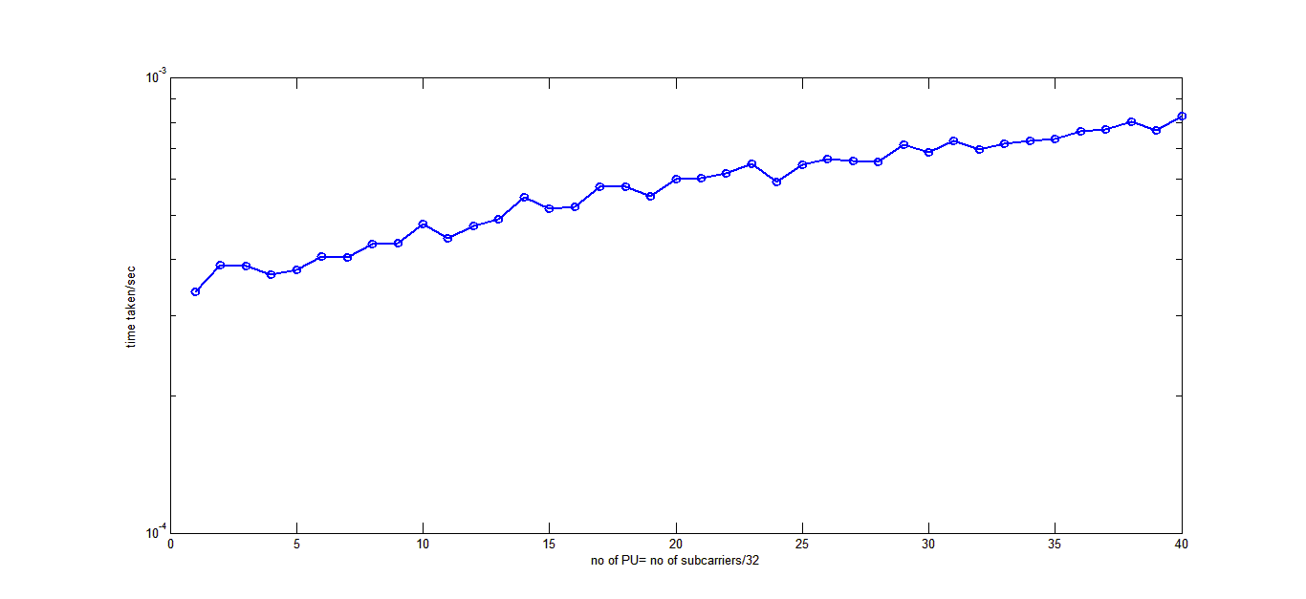

The graph we got has a similar trend as that proposed by the authors of the paper. Our graph appears little jerky because of the lower number of simulation on which we have tested. If the number of simulations were higher there would have been lower fluctuations. Our graph also showed better results when the no of subcarriers were larger. This may be explained that the computer, which we are using, could have better computational power then on which the author tested their algorithm causing our computation to take lower time.

**4. Extra improvement:**

We also tried to get improvement to the given algorithm. One of them was to improve the water-filling algorithm. The water filling algorithm we use currently use has an iterative approach to it, which causes it to take very long time. So one method we used was to change the water-filling algorithm from an iterative to non-iterative method. The codes we developed are given in the later section.

The figure below shows the result of the improvement based on method described in [3]. It is evident that this improved algorithm takes lesser amount of time to perform water filling. There are some jumps here which can be attributed to the fact that each time a new Rayleigh Distributed random vector depicting the channel gains is generated. Moreover, every time a new sub channel or PU is added, the position is random. The position of the new PU also has an automatic effect on the sub-channel power (F, G) constraints mention in Section 3 of the report on which the water filling technique itself depends on.

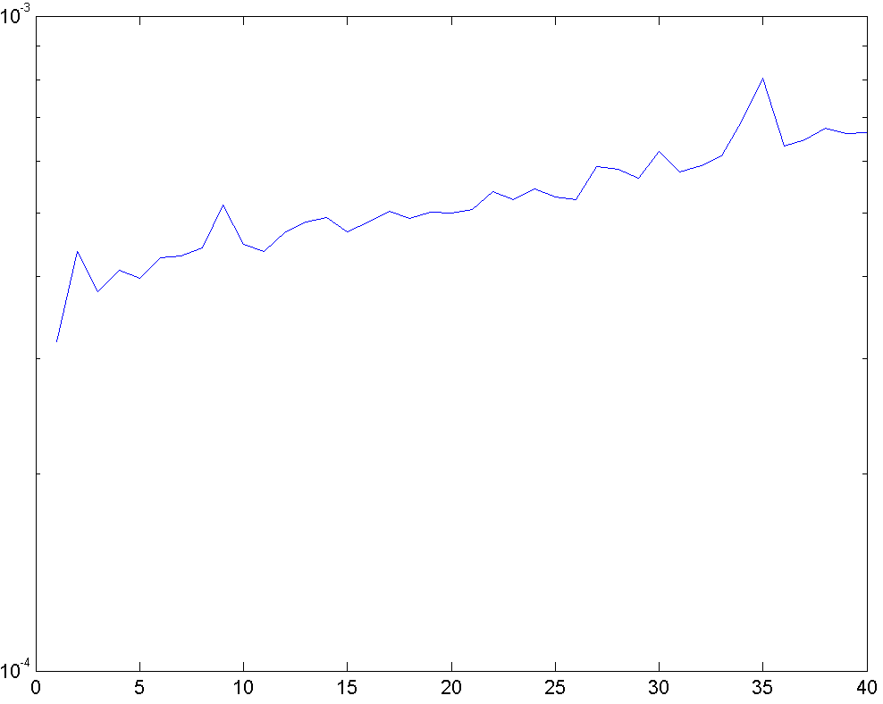

Also we created a simulation in which we can perform the simulation and see how the network evolved with time and how the capacity of network changes with time. Due to timing restriction, we were not able to analyze the performance of algorithm used in the paper. However, for the simulation can be seen for a simple water filling. We also analyzed the effect of doing water filling by using the previous channel information also and found that by having memory in the system the overall performance increased when we used the previous channel noise information.

**5. Codes**

**Simulation using different Water-Filling Functions:**

clc

clear all

close all

%%

ts = 5e-5; % symbol interval

fd = 10; % Hz

chan = rayleighchan(ts,fd);

y = filter(chan,ones(1,1));

% plot(abs(y))

%% creating variables

% Considering only 1/equal subcarriers in each subchannel

bbb=[];

for no_chan=1:1:40; % no of subchannels

subcarriers = 32;

close all

P_tot = 0.01;

CSI = random('rayleigh',1,1,no_chan*subcarriers);

prim_radio=no_chan; % no of primary radios, subchannels

secn_radio=1000; % no of secondary radios

pmax=zeros(prim_radio,1)+1e0; % the maximum power that a radio can transmit

pos_radio_prim=6*rand(2,prim_radio); % the position vector primary

pos_radio_secn=6*rand(2,secn_radio); % the position vector secondary

R = 2; % Each PU's Protection area radius, right now same

d = 1.5*R; % Each SU's interference detection or reliable sensing region, right now same

dist_radio_prim=dist([pos_radio_prim pos_radio_secn]);

dj = dist_radio_prim((prim_radio+1):end,1:prim_radio);

N0 = 1e-10; % Such that N0*B*subcarriers = 1

B = 1/(N0*no_chan*subcarriers);

np=B*N0;

% RADIO RECTANGLES

reclength=.2;

recwidth=.2;

% ENVIRONMENT

figure;

for i=1:max(prim_radio,secn_radio)

grid on

if (i <= secn_radio)

rect=rectangle('Position', [pos_radio_secn(1,i)-reclength/2 pos_radio_secn(2,i)-recwidth/2 reclength recwidth] , 'Curvature', [0 0], 'FaceColor','r');

rect=rectangle('Position', [pos_radio_secn(1,i)-d/2 pos_radio_secn(2,i)-d/2 d d] , 'Curvature', [1 1],'EdgeColor','r');

end

if (i <= prim_radio)

rect=rectangle('Position', [pos_radio_prim(1,i)-R/2 pos_radio_prim(2,i)-R/2 R R] , 'Curvature', [1 1],'EdgeColor','g');

rect=rectangle('Position', [pos_radio_prim(1,i)-reclength/2 pos_radio_prim(2,i)-recwidth/2 reclength recwidth] , 'Curvature', [0 0], 'FaceColor','g');

end

t=num2str(i);

if (i <= prim_radio)

text(pos_radio_prim(1,i)-reclength, pos_radio_prim(2,i)-recwidth,t,'Fontsize',min(reclength,recwidth)*40);

end

if (i <= secn_radio)

text(pos_radio_secn(1,i)-reclength, pos_radio_secn(2,i)-recwidth,t,'Fontsize',min(reclength,recwidth)*40);

end

end

axis equal

% Initially suppose all PU's not transmitting

% N subchannels, N constraints of Pj < Gj

% Each subchannel is allocated to individual PU, each subchannel has

% subcarriers, same right now.

% We are in OSA (In the opportunistic spectrum access (OSA) mode, the SUs

% access the spectrum when the PUs do not use it concurrently) mode

%%

a=[];

% tic

for l = 1:1

% close all

CSI = random('rayleigh',1,1,no_chan*subcarriers);

for j = 1:secn_radio

% Nearest undetectable PU's by the SU's

NU_PU = zeros(1,3);

T1 = find(dj(j,:) - d > 0);

if (~ isempty(T1))

NU_PU = dj(j,T1);

end

% Detectable PU's by the SU's

T2 = find(dj(j,:) - d <= 0);

D_PU = zeros(1,3);

if (~ isempty(T2))

D_PU = dj(j,T2); % Change it if you scale the positions

end

b = -2*ones(1,no_chan); % path attenuation factor

n = (0.5e-2)*ones(1,no_chan); % 5 mW

Gj = zeros(no_chan,2);

Gj(:,2) = n.*((abs(dj(j,:) - R)).^b);

% sum(Gj(:,2)) % Sum Gj's

% Assuming the condition that P_tot < sum Gj's, for P_tot > sum Gj's the

% solution is simply the WFILL on the subcarriers in each subchannel

% individually with the corresponding subchannel transmit power constraint.

% Here subcarriers = subchannels right now.

% Using the IPWF (WFILL_OFDM_NEW)

tic

[Shannon_Capacity, P_i] = WFILL_OFDM_NEW(no_chan*subcarriers,P_tot,CSI,B,N0,Gj(:,2),[],subcarriers,j+1);

a=[a toc];

end

end

bbb=[bbb mean(a)];

end

**Function used for Basic OFDM Water Filling**

function [Shannon_Capacity, P_i] = WFILL_OFDM(No_of_subchan,P_tot,CSI,B,N0)

% No_of_subchan = Number of subchannels in power of 2

% P_tot = Total available power for each OFDM symbol

% CSI = Channel state information "random('rayleigh',1,1,No_of_subchan)"

% B = Total available bandwidth (in Hz)

% N0 = one sided noise spectral dencity (watt/Hz)

noise_pwr = N0*B/No_of_subchan; % Noise power

cnr = CSI.^2/noise_pwr; % carrier to noise ratio

Starting = (P_tot + sum(1./cnr))/No_of_subchan - 1./cnr;

% Initial power allocation

%% Iterative Water Filling

while(~isempty(find(Starting < 0, 1 )))

neg = Starting <= 0;

pos = find(Starting > 0);

REM = length(pos); % Remaining after allocating 0

Starting(neg) = 0; % power to -ve values in Starting

CnrRem = cnr(pos); % allocation.

powerAlloTemp = (P_tot + sum(1./CnrRem))/REM - 1./CnrRem;

Starting(pos) = powerAlloTemp;

end

% Power allocated to each subchannel

P_i = Starting';

% Shannon Capacity

Shannon_Capacity = B/No_of_subchan * sum(log2(1 + Starting.*cnr));

%% Plotting

fig = figure(1);

clf;

bar((Starting + 1./cnr),1,'r')

hold on;

bar(1./cnr,1);

xlabel('Subchannels');

title('Basic OFDM Water Filling')

legend('Power Allocated to Subchannels','Noise to Carrier Ratio')

**Function used for Water Filling (Basic** IPWF**)**

function [Shannon_Capacity, P_i] = WFILL_OFDM_NEW(No_of_subchan,P_tot,CSI,B,N0,Gj,Detected_Gj,subcarriers,Figure)

% No_of_subchan = Number of subchannels in power of 2

% P_tot = Total available power for each OFDM symbol

% CSI = Channel state information "random('rayleigh',1,1,No_of_subchan)"

% B = Total available bandwidth (in Hz)

% N0 = one sided noise spectral dencity (watt/Hz)

% Gj = Gj, the threshold beyond which SU power should

% n't disturb/interference with Undetected PU's

% Detected_Gj = Detected channels, busy PU transmitters detected by SU

% on which water filling is performed.

% subcarriers = no. of subcarriers in each sub-channel

% Figure = Figure no. of Water Filling graph

subchannels = No_of_subchan/subcarriers;

sA = 1:subchannels;

sB = [];

sC = sA;

noise_pwr = N0*B/No_of_subchan; % Noise power

cnr = CSI.^2/noise_pwr; % carrier to noise ratio

Starting = (P_tot + sum(1./cnr))/No_of_subchan - 1./cnr;

% Initial power allocation

%% Iterative Water Filling (Initial)

while(~isempty(find(Starting < 0, 1 )))

neg = Starting <= 0;

pos = find(Starting > 0);

REM = length(pos); % Remaining after allocating 0

Starting(neg) = 0; % power to -ve values in Starting

CnrRem = cnr(pos); % allocation.

powerAlloTemp = (P_tot + sum(1./CnrRem))/REM - 1./CnrRem;

Starting(pos) = powerAlloTemp;

end

% Power allocated to each subchannel

P_i = Starting';

% Shannon Capacity

Shannon_Capacity = B/No_of_subchan * sum(log2(1 + Starting.*cnr));

%% Fj < Gj

Fjs = zeros(1,subchannels);

count = 1;

for i = 1:subcarriers:subcarriers*subchannels

Fjs(count) = sum(Starting(1,i:i+2));

count = count+1;

end

sC = find(Fjs >= Gj');

sA = setdiff(sA,sC);

sB = union(sB,sC);

% sA CNR indices

sA_ind = zeros(1,subcarriers*length(sA));

for i = 1:length(sA)

tmp = subcarriers*(sA(i) - 1) + 1;

sA_ind(subcarriers*(i-1)+1:subcarriers*(i-1)+subcarriers) = tmp:tmp+subcarriers-1;

end

sC_ind = setdiff(1:subcarriers*subchannels,sA_ind);

if (~isempty(sC))

% Performing WF again for newly formed sA

Starting_sA = (P_tot - sum(Fjs(sB)) + sum(1./cnr(sA_ind)))/length(sA_ind) - 1./cnr(sA_ind);

while(~isempty(find(Starting_sA < 0,1)))

neg = Starting_sA <= 0;

pos = find(Starting_sA > 0);

REM = length(pos); % Remaining after allocating 0

Starting_sA(neg) = 0; % power to -ve values in Starting

CnrRem = cnr(pos); % allocation.

powerAlloTemp = (P_tot - sum(Gj(sB)) + sum(1./CnrRem))/REM -1./CnrRem;

Starting_sA(pos) = powerAlloTemp;

end

Starting(sA_ind) = Starting_sA;

for i = 1:length(sC)

tmp = sC_ind(subcarriers*(i-1)+1:subcarriers*(i-1)+subcarriers);

Starting(tmp) ...

= (Gj(sC(i)) + sum(1./cnr(tmp)))/length(tmp) - 1./cnr(tmp);

end

end

% Plotting

% figure(Figure);

% clf;

% bar((Starting + 1./cnr),1,'r')

% hold on;

% bar(1./cnr,1);

% xlabel('Subchannels');

% title('Basic OFDM Water Filling')

% legend('Power Allocated to Subchannels','Noise to Carrier Ratio')

**Function used for Water Filling (Efficient** IPWF**) [3]**

function [Shannon_Capacity, P_i] = WFILL_OFDM_NEW_NEW(No_of_subchan,P_tot,CSI,B,N0,Gj,Detected_Gj,subcarriers,Figure)

% No_of_subchan = Number of subchannels in power of 2

% P_tot = Total available power for each OFDM symbol

% CSI = Channel state information "random('rayleigh',1,1,No_of_subchan)"

% B = Total available bandwidth (in Hz)

% N0 = one sided noise spectral dencity (watt/Hz)

% Gj = Gj, the threshold beyond which SU power should

% n't disturb/interference with Undetected PU's

% Detected_Gj = Detected channels, busy PU transmitters detected by SU

% on which water filling is performed.

% subcarriers = no. of subcarriers in each sub-channel

% Figure = Figure no. of Water Filling graph

subchannels = No_of_subchan/subcarriers;

sA = 1:subchannels;

sB = [];

sC = sA;

noise_pwr = N0*B/No_of_subchan; % Noise power

cnr = CSI.^2/noise_pwr; % carrier to noise ratio

H_inv = 1./cnr;

Starting = (P_tot + sum(H_inv))/No_of_subchan - H_inv;

% Initial power allocation

%% Iterative Water Filling (Initial)

while(~isempty(find(Starting < 0, 1 )))

neg = Starting <= 0;

pos = find(Starting > 0);

REM = length(pos); % Remaining after allocating 0

Starting(neg) = 0; % power to -ve values in Starting

CnrRem = cnr(pos); % allocation.

powerAlloTemp = (P_tot + sum(1./CnrRem))/REM - 1./CnrRem;

Starting(pos) = powerAlloTemp;

end

% Power allocated to each subchannel

P_i = Starting';

% Shannon Capacity

Shannon_Capacity = B/No_of_subchan * sum(log2(1 + Starting.*cnr));

%% Fj < Gj

Fjs = zeros(1,subchannels);

count = 1;

for i = 1:subcarriers:subcarriers*subchannels

Fjs(count) = sum(Starting(1,i:i+2));

count = count+1;

end

sC = find(Fjs >= Gj');

sA = setdiff(sA,sC);

sB = union(sB,sC);

Len_sA = length(sA);

Len_sB = length(sB);

W_LEVELs = Starting + H_inv; % Water Level

w_lev = Starting(1) + H_inv(1); % Water Level

delta_N = (Fjs - Gj');

delta_N1 = delta_N(sA)/Len_sA;

sQ1 = find(H_inv(sA) <= w_lev);

sR1 = find((w_lev < H_inv(sA)) & (H_inv(sA) < w_lev - delta_N1));

sS1 = setdiff(sA,[sQ1 sR1]);

Len_sQ1 = length(sQ1);

Len_sR1 = length(sR1);

Len_sS1 = length(sS1);

w_lev1 = w_lev - delta_N1 + (sum(H_inv(sA) - w_lev) + Len_sS1*delta_N1)/(Len_sQ1 + Len_sR1);

W_LEVELs(sA) = w_lev1;

delta_N2 = -delta_N(sB)/Len_sB;

sC1 = find(H_inv(sB) <= w_lev + delta_N2);

sD1 = find(H_inv(sB) > w_lev + delta_N2);

Len_sC1 = length(sC1);

Len_sD1 = length(sD1);

w_lev2 = w_lev - delta_N2 - sum(min(H_inv(sB) - w_lev + delta_N2,delta_N2));

W_LEVELs(sB) = w_lev2;

%% Plotting

% figure(Figure);

% clf;

% bar(W_LEVELs,1,'r')

% hold on;

% bar(1./cnr,1);

% xlabel('Subchannels');

% title('Basic OFDM Water Filling')

% legend('Power Allocated to Subchannels','Noise to Carrier Ratio')

**References**

[1] FCC, Spectrum Policy Task Force Report, ET Docket No. 02-135. Nov 2002.

[2] J. Mitola and G. Q. Maguire: Cognitive radio: making software radios more personal, IEEE Pers. Commun. Mag. vol. 6, no. 4, pp13- 18, Aug.1999.

[3] Qi, Qilin and Yang, Yaoqing Lamar ”An Efficient Water-Filling Algorithm for Power Allocation in OFDM-Based Cognitive Radio Systems” (2012). CSE Conference and Workshop Papers. Paper 196.

[4] Simon Haykin: Cognitive Radio: Brain-Empowered Wireless Communications, Invited Paper, IEEE Journal on selected areas in communications, vol. 23, no. 2, Feb. 2005

[5] Wei Yu, J. M. Cioffi: On constant power water-filling, IEEE International Conference on Communications, vol.6, no., pp.1665- 1669 vol.6, 2001.

[6] T. Yoo, A. Goldsmith: ”Capacity an power allocation for fading MIMO channels with channel estimation error, IEEE Transactions on Information Theory, vol.52, no.5, pp.2203-2214, May 2006.

[7] G. Bansal, J. Hossain, V. K. Bhargava: Optimal and Suboptimal Power Allocation Schemes for OFDM-based Cognitive Radio Systems, IEEE Transactions on Wireless Communications, vol.7, no.11, pp.4710-4718, November 2008.

[8] Xin Kang, Ying-Chang Liang, A. Nallanathan, H. K. Garg, Rui Zhang: Optimal power allocation for fading channels

in cognitive radio networks: Ergodic capacity and outage capacity, IEEE Transactions onWireless Communications, vol.8, no.2, pp.940-950, Feb.2009

[9] Majed Haddad, Aawatif Menouni Hayar and Merouane Debbah Spectral efficiency of Cognitive Radio systems

[10] Amna Saad Kamil,Ibrahim Khider: “Open Research issues in Cognitive Radio” 16th Telecommunications forum TELFOR 2008, Serbia, Belgrade, November, 25-27, 2008

[11] Ziaul Hasan, Ekram Hossain, Charles Despins, and Vijay K. Bhargava: “Power Allocation for Cognitive Radios Based on Primary User Activity in an OFDM System”

[12] Kennedy Ifeh: “Transmit-power control for cognitive radio networks: Challenges, requirements and options”

[13] Fan Wang, Marwan Krunz, and Shuguang Cui: “Spectrum Sharing in Cognitive Radio Networks”

[14] P. Wang, et al., “Power allocation in OFDM-based cognitive radio systems,”in Proc. IEEE Global Telecommun.