Water Filling Algorithms for Power Allocation and Control in Cognitive Radio Systems

Kamran Ali (13100174@lums.edu.pk)
Isfar Tariq (13100151@lums.edu.pk)
Spring 2013

Introduction
With the rapid development of wireless communications, frequency spectrum is becoming a very precious resource and scarcity of the spectrum is a serious problem. In some cases, the spectrum bands are not efficiently utilized because licensed users do not always occupy their spectrum and unlicensed users are not allowed to operate in such spectrum bands. This governance leads to unbalanced spectrum utilization [1] [4].

In [2] Joseph Mitola proposed Cognitive radio (CR) systems to exploit the unbalanced spectrum utilization and by allowing Secondary Users (SUs) to use the idle spectrum of licensed users or Primary Users (PUs) to gain a higher spectrum utilization. Hakin defines cognitive radio like this in one of his most cited papers [4]:

“Cognitive radio is an intelligent wireless communication system that is aware of its surrounding environment (i.e., outside world), and uses the methodology of understanding-by-building to learn from the environment and adapt its internal states to statistical variations in the incoming RF stimuli by making corresponding changes in certain operating parameters (e.g., transmit-power, carrier-frequency, and modulation strategy) in real-time, with two primary objectives in mind:
• Highly reliable communications whenever and wherever needed
• Efficient utilization of the radio spectrum.”

Different algorithms have been developed to detect the available spectrum bands of the PUs which include some simple and easy implementation as well. However, the transmit-power control and dynamic management on these spectrums bands is a major challenge faced by Cognitive Radio research community.

Various algorithm have been proposed in this domain and Water Filling (WF) algorithms are the most prevalent. [4] Discusses basic the essence of transmit-power control for such a non-cooperative multiuser radio environment, defines the terminologies, the optimization criteria, conditions etc. and then presents a distributive, multiuser and iterative WF algorithm (shown in figure below as well). [5] [6] also present water-filling algorithms for traditional power allocation problems. Because additional interference constraints must be considered in cognitive radio networks, the water-filling algorithms are always performed iteratively to solve the power allocation problem [7] [8]. [3] Proposes a linear iterative algorithm for Power Allocation in Orthogonal Frequency Division Multiplexing (OFDM)-Based Cognitive Radio Systems to reduce computational complexity. We will try to study the mentioned approaches and compare their performance in terms of their complexity and efficient utilization of bandwidth.
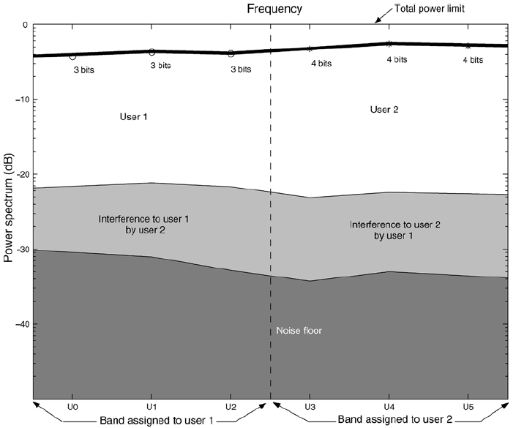
[4]
Schedule
According to the tentative division, this project will proceed in four parts. The first three parts are the main deliverables and thus the necessary ones where as the third part will be prioritized and attempted as time permits.
- Background Literature Review:
Further reading of different Water Filling (WF) Algorithms related to Power Allocation over Cognitive Radio Systems the problem followed by a complete survey of various techniques specially the cross-layer approaches.
- Comparison of Techniques:
The techniques will be compared on theoretical basis e.g. based on the parameters like Computational Complexity, Communication Overhead, etc. If time permits all the reviewed techniques will be simulated in MATLAB as well. However, if due to time limits we don’t simulate all of them we still be able to select and finalize an efficient WF algorithm.
- MATLAB Simulation:
The finalized WF algorithm will be simulated on MATLAB where we will be replicating the results presented in the research paper containing the specific technique.
- Further Study and Novel Contributions:
After careful observation and critical analysis of the simulation results, the problems that might not have been considered in the previous approaches will also be considered. Thus, if time permits, we will try to come up with some novelty on our part by suggesting and simulating some improvements.

References

[1] FCC, “Spectrum Policy Task Force Report,” ET Docket No. 02-135. Nov 2002.

[2] J. Mitola and G. Q. Maguire, “Cognitive radio: making software radios more personal,” IEEE Pers. Commun. Mag. vol. 6, no. 4, pp13- 18, Aug.1999.

[3] Qi, Qilin and Yang, Yaoqing Lamar, "An Efficient Water-Filling Algorithm for Power Allocation in OFDM-Based Cognitive Radio Systems" (2012). CSE Conference and Workshop Papers. Paper 196.

[4] Simon Haykin,, “Cognitive Radio: Brain-Empowered Wireless Communications”, Invited Paper, IEEE Journal on selected areas in communications, vol. 23, no. 2, Feb. 2005

[5] Wei Yu; J. M. Cioffi, “On constant power water-filling,” IEEE International Conference on Communications, vol.6, no., pp.1665- 1669 vol.6, 2001.

[6] T. Yoo, A. Goldsmith, "Capacity an power allocation for fading MIMO channels with channel estimation error,” IEEE Transactions on Information Theory, vol.52, no.5, pp.2203-2214, May 2006.

[7] G. Bansal, J. Hossain, V. K. Bhargava, “Optimal and Suboptimal Power Allocation Schemes for OFDM-based Cognitive Radio Systems,” IEEE Transactions on Wireless Communications, vol.7, no.11, pp.4710-4718, November 2008.

[8] Xin Kang, Ying-Chang Liang, A. Nallanathan, H. K. Garg, Rui Zhang, “Optimal power allocation for fading channels in cognitive radio networks: Ergodic capacity and outage capacity,” IEEE Transactions on Wireless Communications, vol.8, no.2, pp.940-950, Feb.2009

